MoonLite’s NiteCrawler
2 Axis Rotating Worm Drive Focuser

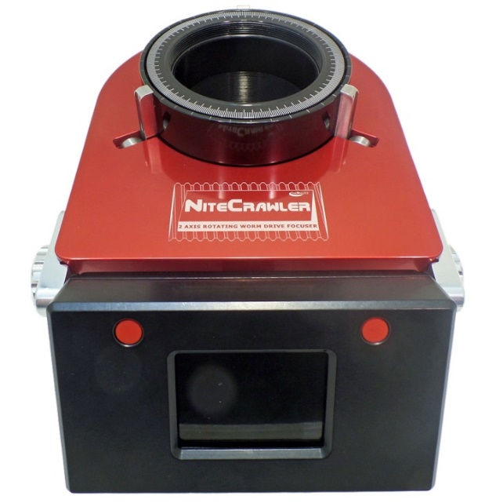
MoonLite’s NiteCrawler is a fully electronic focuser using fly by wire control technology for very accurate positioning. The lead screws provide large 25 lb. load capacity with extreme resolution / repeatability. The focuser holds heavy loads even with the power off and remembers position on power up, no need to re-home each time.

The NiteCrawler is offered in three sizes:
WR25 2.5” format $2400
WR30 3.0” format $2650
WR35 3.5” format $2900

Specifications:
- 25 lb. instrument load capacity
- 2 axis no backlash lead screws
- Rotating drawtube .001 degree resolution
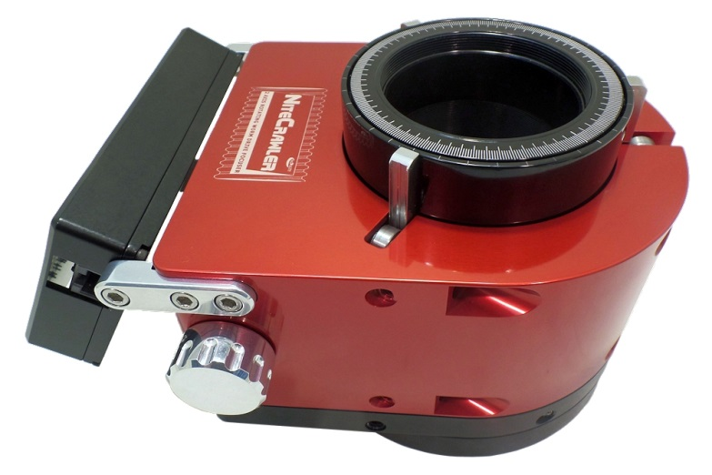
- WR25 374,920 steps per revolution
- WR30 444,080 steps per revolution
- WR35 505,960 steps per revolution
- Aprox 1” travel, 94,580 steps per inch resolution
- Large ½” high capacity bearings
- 3 point stainless steel linear rails
- 5 jog rates with 32 indent encoder knobs
- Left knob rotation & Aux focuser/ Right knob focus
- Eccentric cam bearing collimation system
- Remote temperature probe
- ASCOM / non-ASCOM / SKYX
- Auxiliary motor port for mini worm OAG focuser
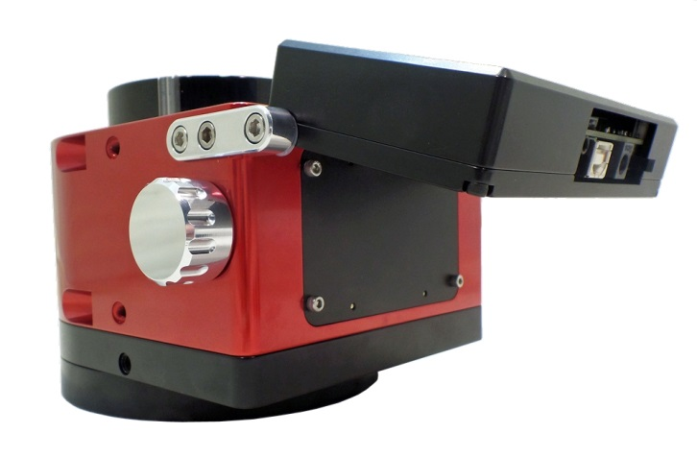
- Most flange sizes in stock. Custom available.
- 6 custom anodized colors
- 12 volt / 400mA (both motors running), 200mA (Idle)
- 6 lb. weight
- Flange extenders available for adjusting profile
- Thread in adapters for all cameras available
- Drawtube extender rings available .5” , 1”, 2” sizes
- 3.8” min profile

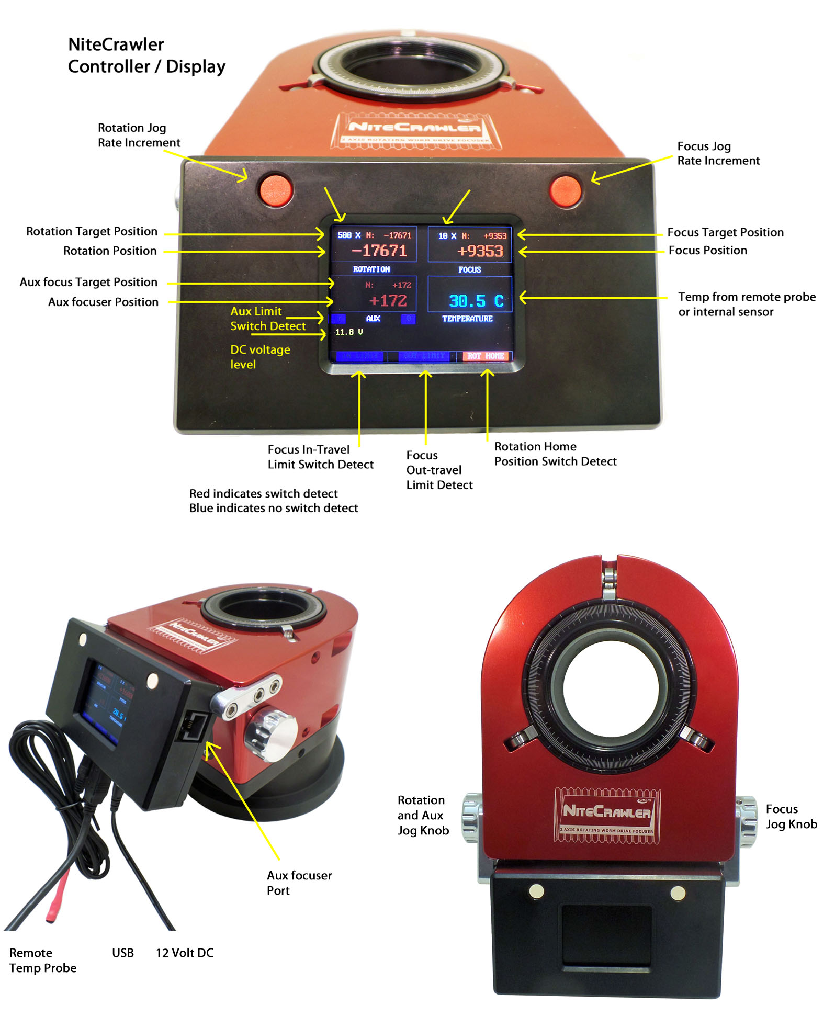

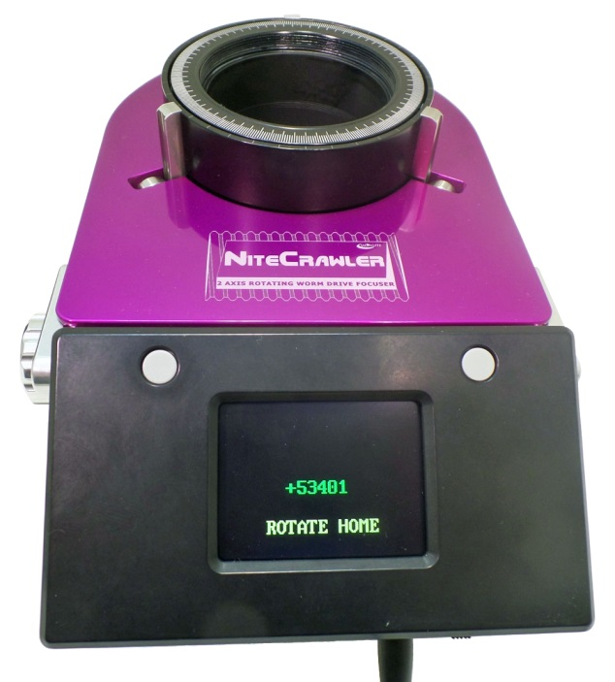
Auto Calibrate Mode- Hold down the right button while turning power on. Let go of the button once the display comes up. The focuser will rotate in a CW direction finding the rotate home position first. It will then rack the drawtube down to find vertical focus home positon. This can take from 1 to 10 mins.

Note the limit indicator will go from Blue to Red when any of the magnetic position sensors are detected.

Auto Calibrate needs to only be done once, as the focuser remains at and remembers its last position when turned back on. However, the focuser can be re-Calibrated any time, even remotely using SW. This can be handy if cables get twisted or the focuser mechanical hots something to limit its motion. The motors are designed to simply stall if the focuser’s movement is restricted.
No harm will come to the drive systems, but a stall situation will require
Re-calibrating the focuser.
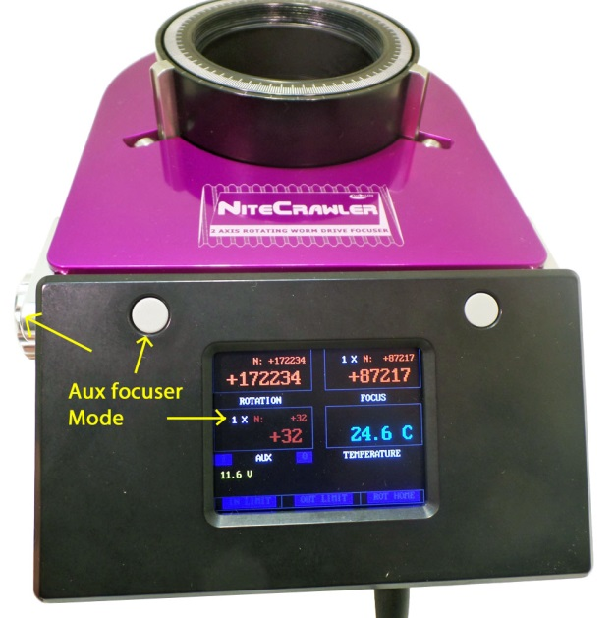

The Aux focuser ( if connected) can be ran using the
left jog knob. Hold down the left Menu button for 3 seconds.
The left jog knob will now operate the Aux focusers postion.
Notice the 1 X rate indicator turns on in the AUX display area and turns off in the rotation area. To switch back, just hold the button down for 3 seconds again to change back to Rotation mode.

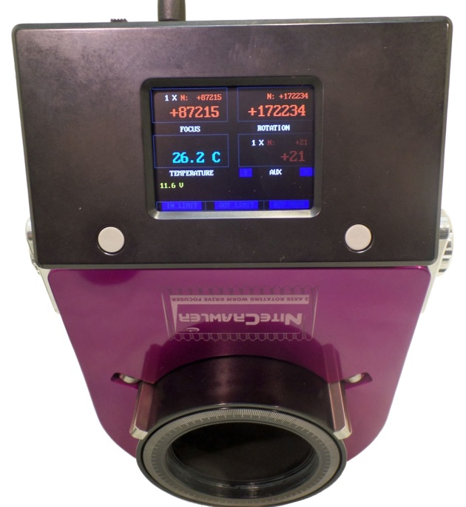

Inverted display mode is activated by holding down the Right side menu button for 3 seconds. Hold down again to revert back to normal up-right display mode.

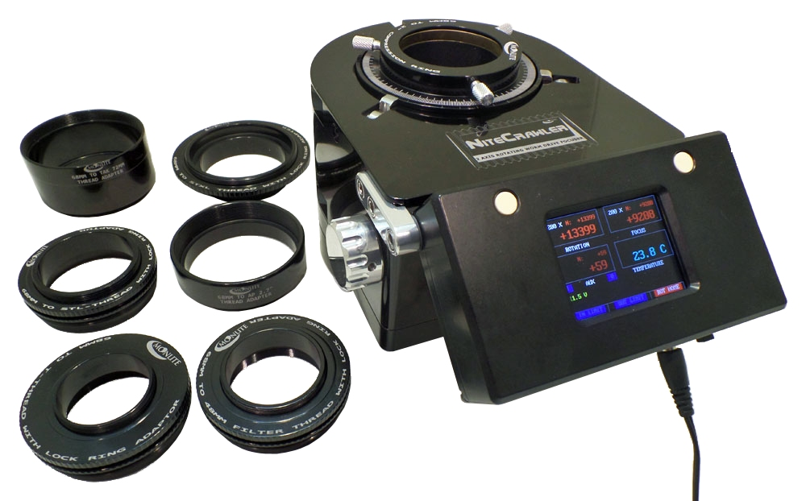

Moonlite provides many adapters to provide an all threaded rigid connection to any imaging system.
WR25 model uses 68mm threaded adapters $79 any size/style
WR30 model uses 80mm threaded adapters $89 any size/style
WR35 model uses 92mm threaded adapters $99 any size/style

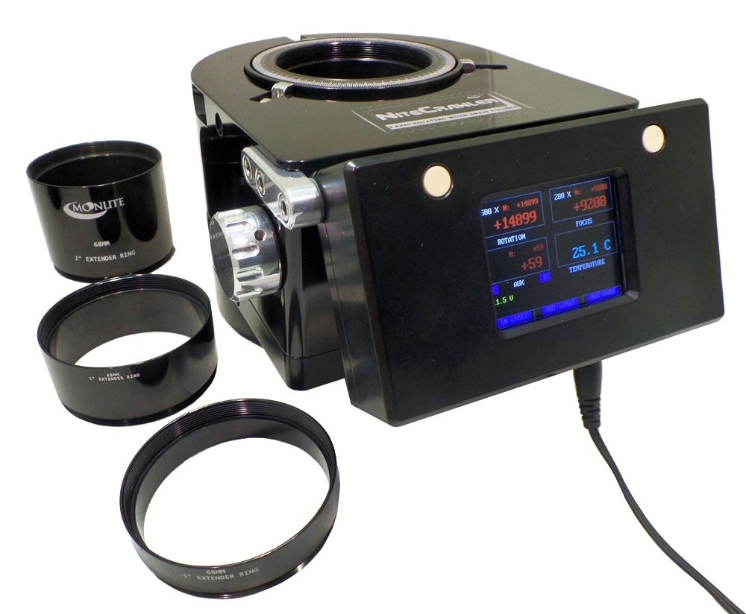

Drawtube extender kits are available for all 3 models. They consist of a ½”, 1”, and 2” drawtube extenders.
WR25 Drawtube Extender kit $169
WR30 Drawtube Extender kit $199
WR35 Drawtube Extender kit $229
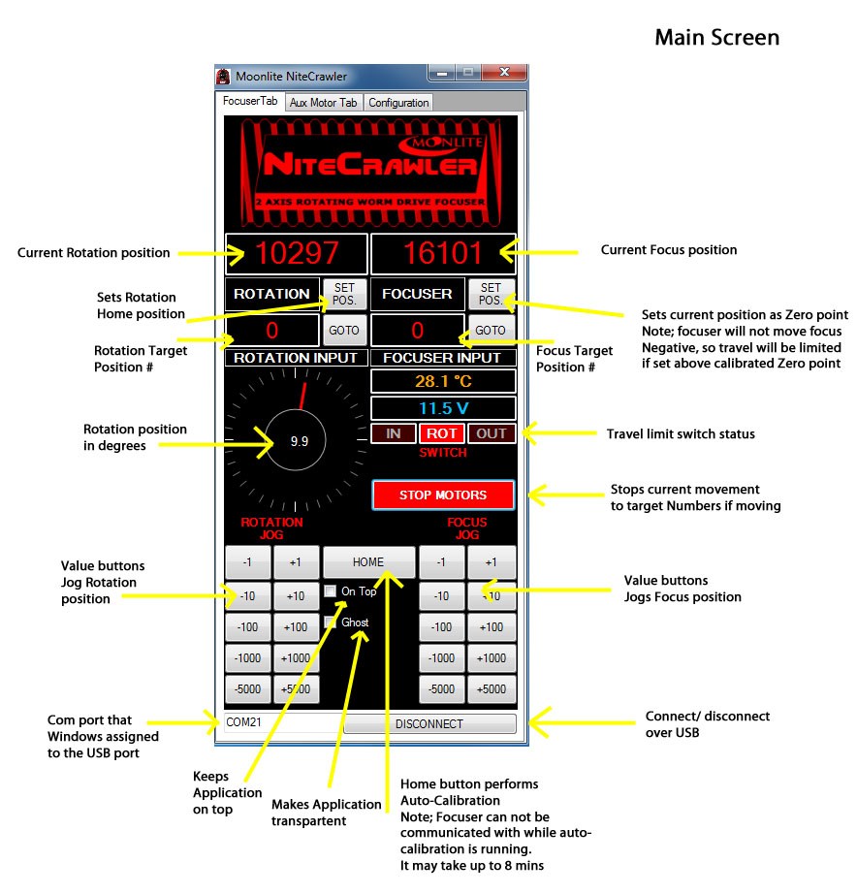

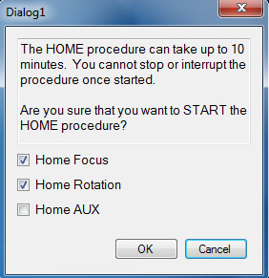
Home button will bring up a selection box for picking
axis to calibrate. Note: this is the only way to home
the Aux focuser if connected, as there is no manual
access from the main NiteCrawler’s controller. Home
procedure can vary in time from 1 to 10mins depending
on the size/ model of the focuser and how far away the
magnetic home switches are from the current position.
The focuser will disconnect from the PC during any
home procedure. Just wait for it to complete, and then
click on connect to resume control.

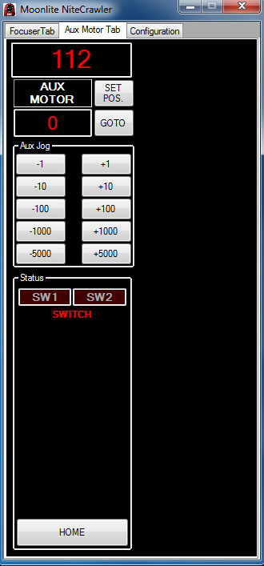

The Aux Motor Tab allows control of devises plugged
In to the Auxiliary Port located on the side of the
controller.

2 future options will be available, a Mini Worm focuser
for OAG focus control, or optional Automated Dust
Cap / Shutter system.

The Aux port can be controlled just like the other ports
On the Nitecrawler focuser including magnetic limit switches, and full positional control.

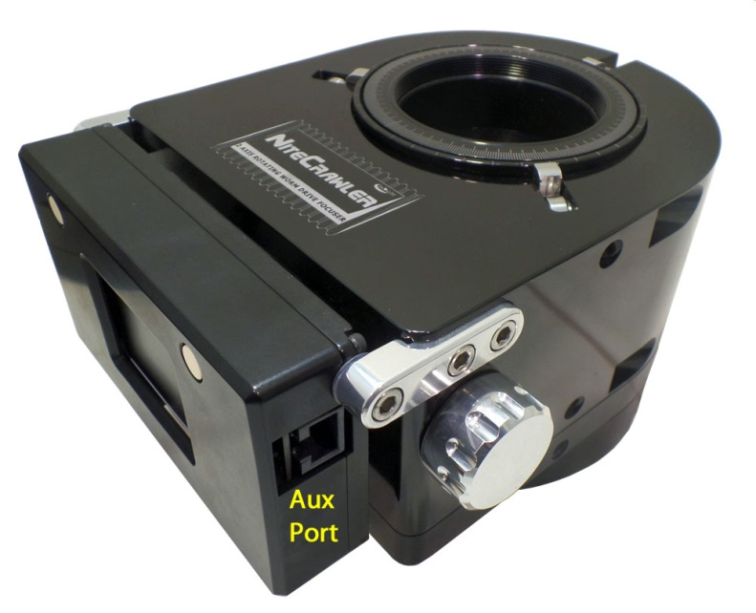

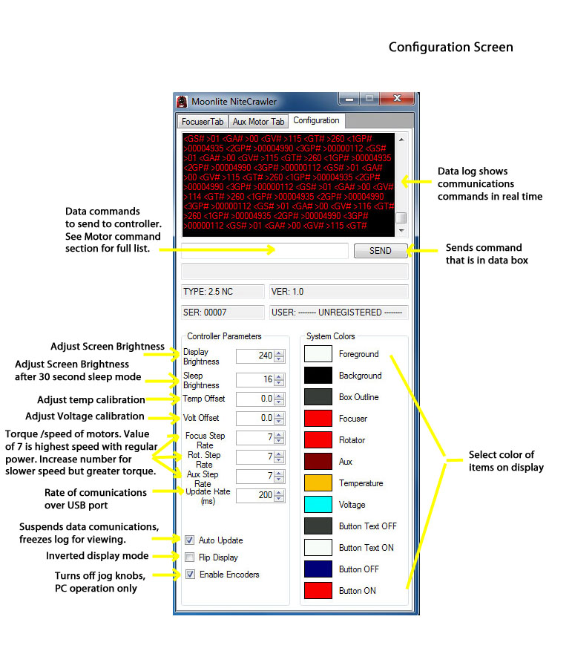

MoonLite Non ASCOM utility program for NiteCrawler focusers and our Beta ASCOM driver is listed under the Download tab on the Moonlite Web page http://focuser.com/downloads.php

MoonLite’s NiteCrawler non-ASCOM program is designed to run only 2 axis NiteCrawler focusers. It will not work with other MoonLite controllers. No ASCOM is required to run this utility program but Microsoft .NET Framework 4 needs to be turned on in Windows for the installation. This install procedure is the same for all MoonLite non-ASCOM utility programs.

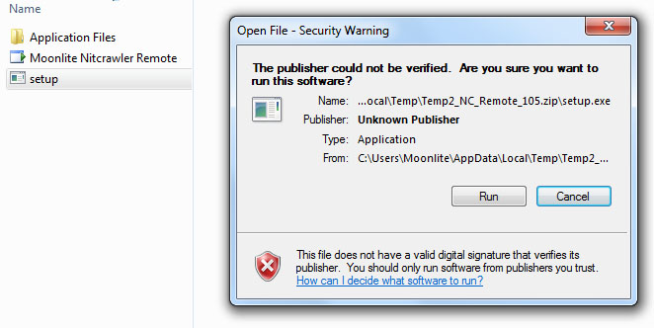
Download NiteCrawler non ASCOM utility program - NC_v1_1_10.zip from our download page and extract the files to the default folder it requires. Please note the PC should have internet connectivity for any updates windows may need to perform during the installation.
Before running Setup, ensure that you have Microsoft .NET Framework 4 installed on your computer. This can be verified via: Control Panel/Add or Remove Programs. If Microsoft .NET Framework 4 is not installed on your machine, you can download it here: http://www.microsoft.com/downloads/en/details.aspx?FamilyID=9cfb2d51-5ff4-4491-b0e5-b386f32c0992&displaylang=en . Windows will access the web and update Net framework automatically if needed once you start installation. Next, verify your controller is connected to your PC and turned on. Click on the Zip file to start the installation. Run "Setup”: Be patient, the program will verify that you have the correct .NET Framework and will populate a list of Com Ports in use. Continue with the installation and the program will launch.

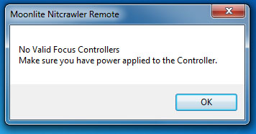
If the program will not connect to the focuser, or says no valid focuser controller found then check to make sure your PC has the correct USB driver. To install the driver download the VCP (virtual com port) driver for the FT232R chip from http://www.ftdichip.com/Drivers/VCP.htm

Install the NiteCrawler Beta ASCOM driver -- NiteCrawler-Setup.zip is also listed on the website under downloads.

Mechanical Adjustments

Collimation is factory set on a bench with a laser, but customers can change it by adjusting the 6 offset cam bearing holders. Please see Video for mechanical adjustment procedures.

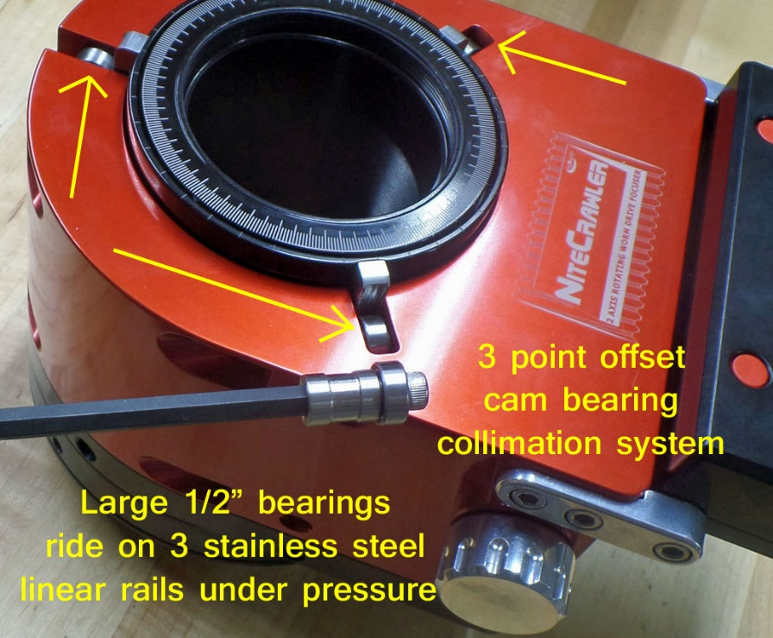

Focuser orientation can be adjusted after threading focuser onto OTA.

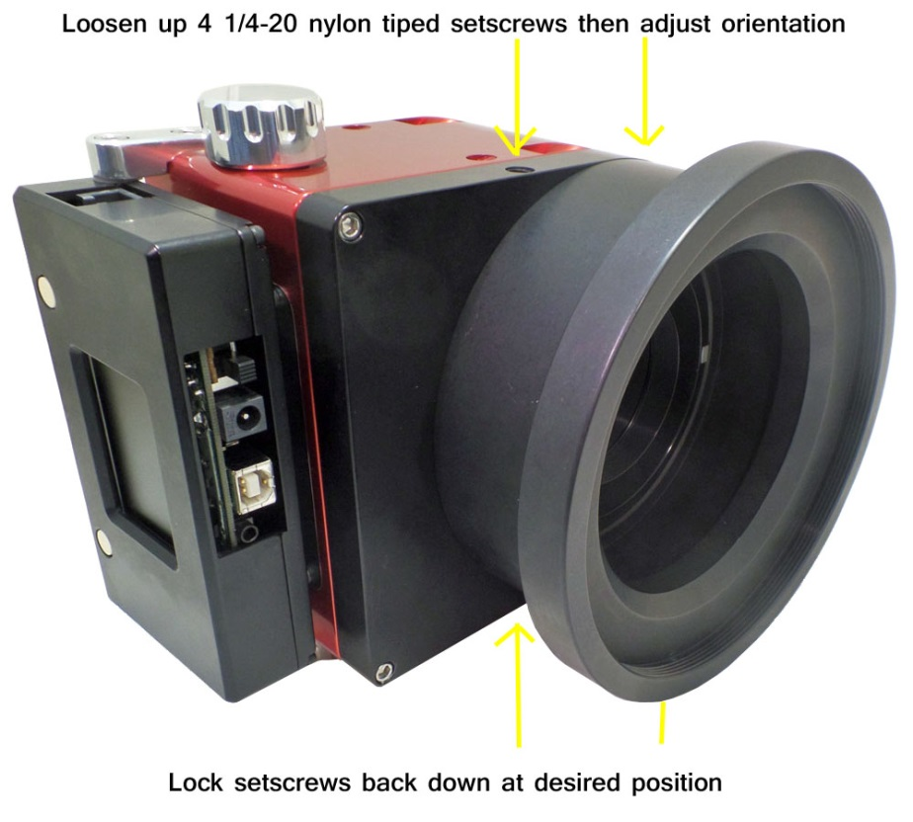

NiteCrawler drawtubes are threaded on the bottom to hold focal reducers inside the drawtube.

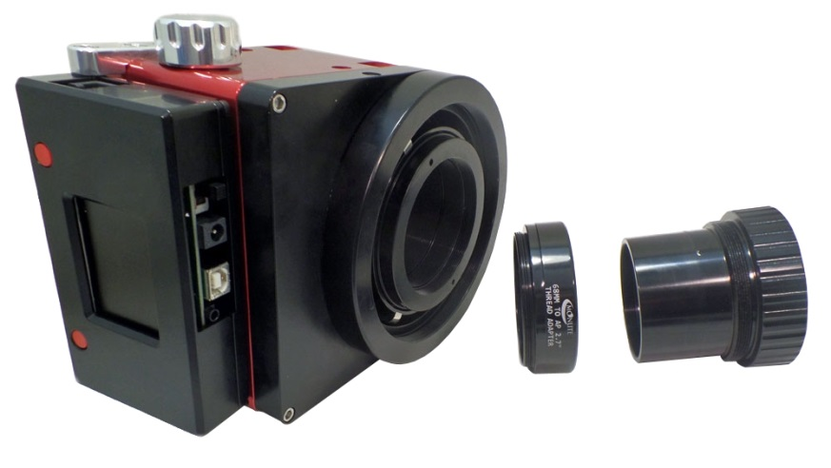
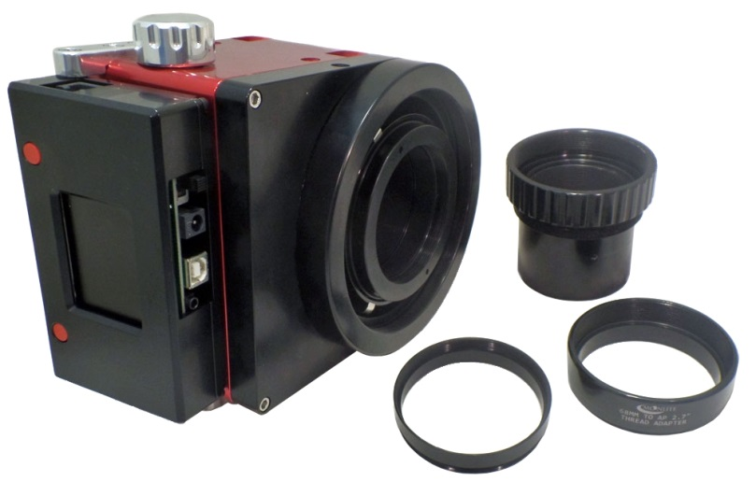

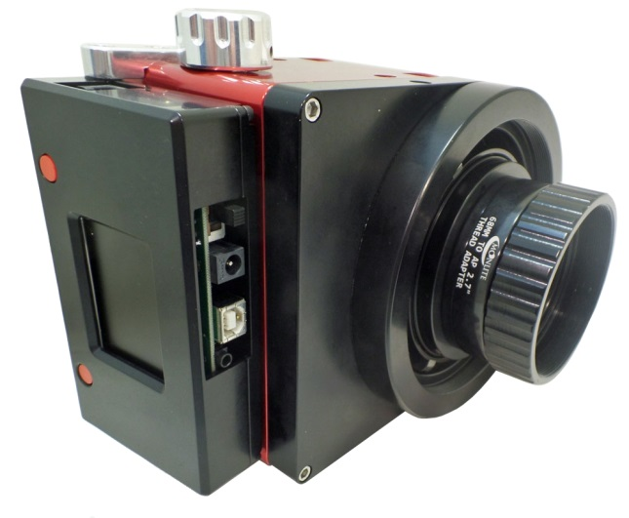
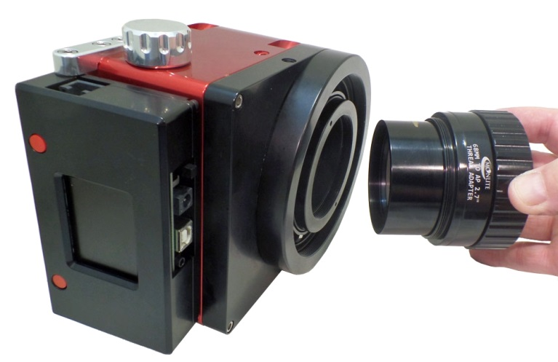

The above example shows an AP27 reducer being installed into the bottom of the focuser’s drawtube. This focuser has a flange installed with a 117mm thread for an RC 12” scope. The focuser is then thread onto the back of the RC scope with the reducer hanging off the bottom of the drawtube but positioned in the spacer ring area. The reducer simply travels with the drawtube maintaining the correct distance to the camera sensor. Note: spacing considerations were made to place the reducer at the correct distance to the sensor when at focus using drawtube extender rings on the top of the focuser camera side.

MoonLite Telescope Accessories
755 Preserve Road
Danville PA 17821
(570) 437-2232
www.focuser.com

