Installing DC motor or High res stepper motor on CR model focuser
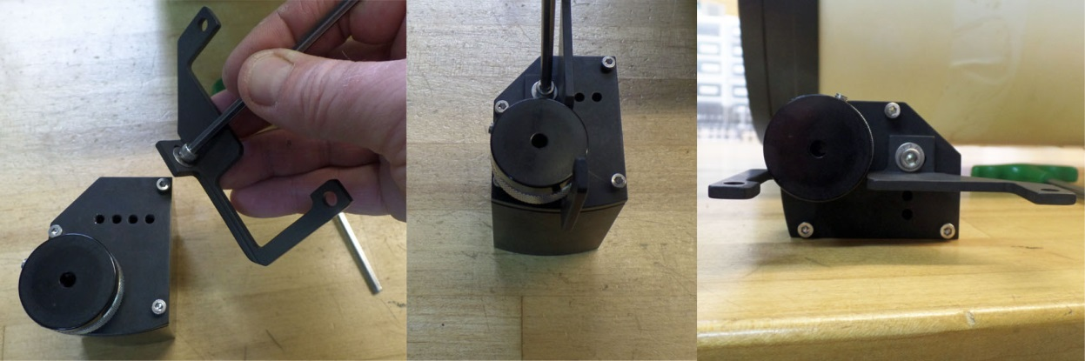

Install bracket in top hole location. Do not tighten up, let loose for now
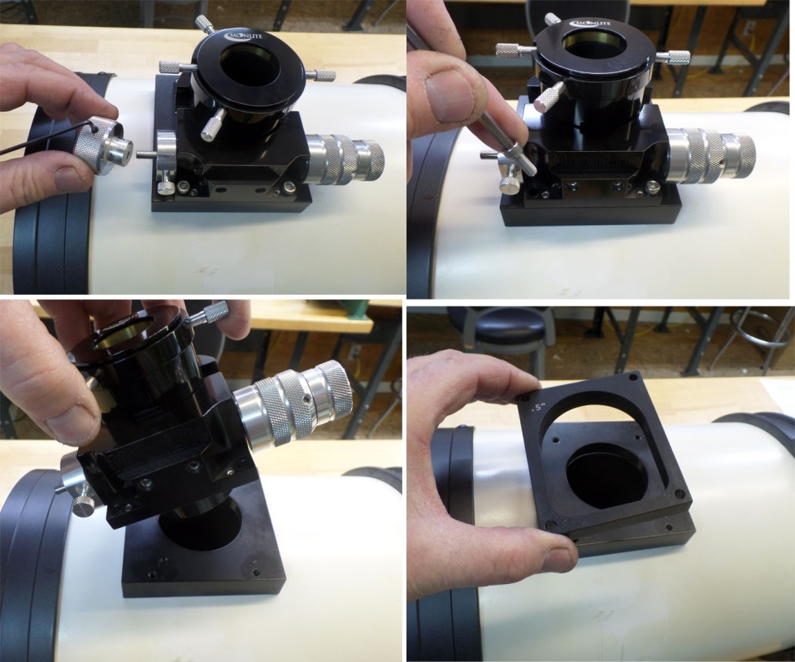

Remove Left side knob
Remove mounting bolt
Install any require spacers at this time if clearance is needed
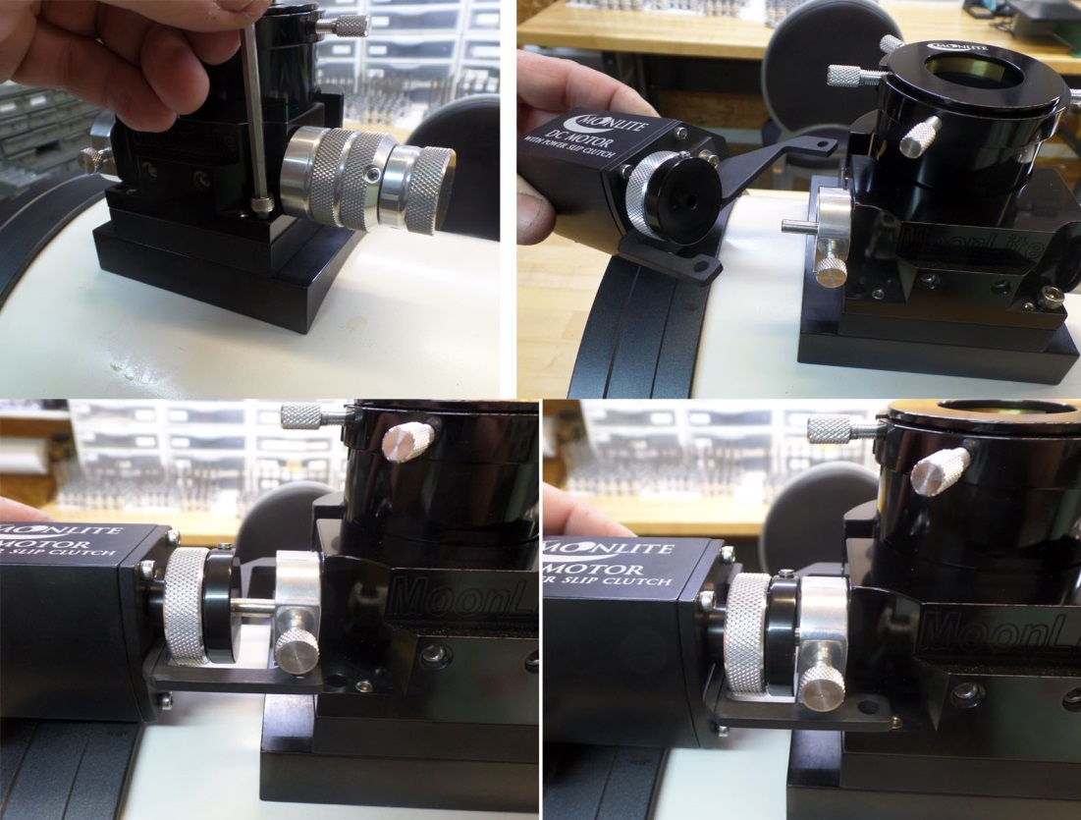

Tighten up bolts on non motor side
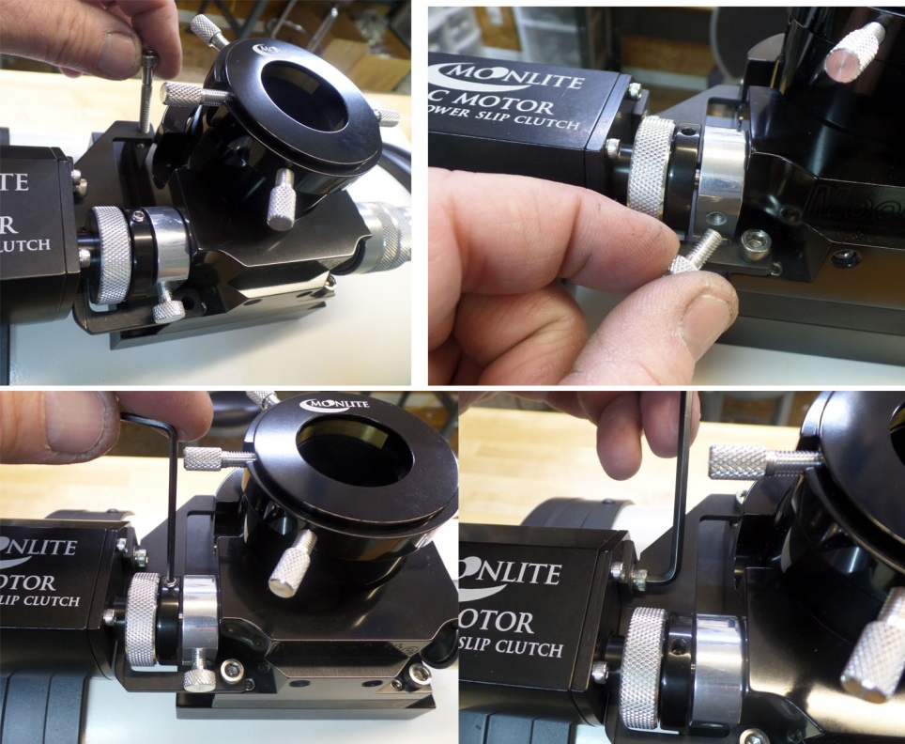
Slide motor and clutch on to shaft

Tighten up set screw on motor clutch and remove old lock knob
Once everything is in position, tighten up set screw on bracket

